K L UNIVERSITY
FRESHMAN ENGINEERING DEPARTMENT

A Project Based Lab Report On
SMART FINANCE MANAGER & PERSONAL EXPENSE INTELLIGENCE SYSTEM

SUBMITTED BY:
ID NUMBER NAME
2500031035 K Nikhitha Sri
2500031214 K Tarun Kumar
2500031441 U Deekshitha
2500031318 N Rahul

UNDER THE ESTEEMED GUIDANCE OF K SAI SANDEEP
ASSISTANT PROFESSOR



KL UNIVERSITY
Green fields, Vaddeswaram – 522 502 Guntur Dt., AP, India.

DEPARTMENT OF BASIC ENGINEERING SCIENCES



CERTIFICATE

This is to certify that the project based laboratory report entitled “SMART FINANCE MANAGER & PERSONAL EXPENSE INTELLIGENCE SYSTEM” submitted by K Nikhitha Sri, K Tarun Kumar, U Deekshitha, N Rahul bearing Regd. No. 2500031035, 2500031214, 2500031441, 2500031318 to the Department of BES-1 , KL University in partial fulfillment of the requirements for the completion of a project based Laboratory in “Python Programming (25SC2007)” course in Semester II, is a Bonafede record of the work carried out by him/her under my supervision during the academic year 2025 – 2026.

PROJECT SUPERVISOR HEAD OF THE DEPARTMENT K SAI SANDEEP K Dr. D. HARITHA

ACKNOWLEDGEMENTS

It is a great pleasure for me to express my gratitude to our honorable President.

Sri. Koneru Satyanarayana, for giving the opportunity and platform with facilities in accomplishing the project-based laboratory report.
I express sincere gratitude to our Director Dr. A. Jagdeesh for his administration towards our academic growth.
I express sincere gratitude to our Coordinator and HOD-BES Dr. D. Haritha for her leadership and constant motivation provided in successful completion of our academic semester. I record it as my privilege to deeply thank you for providing us with the efficient faculty and facilities to make our ideas into reality.
I express my sincere thanks to our project supervisor K SAI SANDEE for his novel association of ideas, encouragement, appreciation, and intellectual zeal which motivated us to venture this project successfully.
Finally, we are pleased to acknowledge our indebtedness to all those who devoted themselves directly or indirectly to making this project a success.

Name: K Nikhitha Sri
K Tarun Kumar
U Deekshitha
N Rahul

ID No: 2500031035
2500031214
2500031441
2500031318

ABSTRACT

The Smart Finance Manager & Personal Expense Intelligence System (SFM-PEIS) is a Python-based application developed to help users manage their personal finances effectively. It includes features such as transaction tracking, expense categorization, budgeting, subscription management, and financial analysis. By using concepts like data structures, object-oriented programming, and libraries such as NumPy, Pandas, and Matplotlib, the system provides meaningful insights into spending patterns, detects unusual transactions, and helps users understand their financial behaviour better.

In today’s fast-paced world, people often find it difficult to track expenses and plan their finances properly. This system solves that problem by offering a structured and intelligent approach to financial management. It not only records transactions but also analyses data to predict future expenses and identify financial risks. With features like visualization and automated categorization, users can make better financial decisions and improve their overall financial stability.

INDEX

S.NO | TITLE | PAGE NO
1 | Introduction | 6
2 | Aim of the Project | 7
2.1 | Advantages & Disadvantages | 8
2.2 | Future Implementation | 8
3 | Software & Hardware Details | 9
4 | Data Flow Diagram | 10-11
5 | Algorithm for each module | 12
6 | Implementation | 13-15
7 | Integration and System Testing | 16-18
8 | Conclusion | 19

INTRODUCTION

In today’s world, managing personal finances has become increasingly complex due to multiple payment methods, subscriptions, and daily expenses. Many people struggle to track their spending, plan budgets, and detect financial irregularities. Existing applications provide solutions but are often closed systems.

The SFM-PEIS project provides an open, customizable solution built using Python. It allows users to manage their finances effectively by integrating multiple modules such as transaction management, expense categorization, budgeting, analytics, and visualization. The system not only stores financial data but also converts it into meaningful insights, helping users make better financial decisions.

Overall, the SFM-PEIS project acts as a complete personal finance solution by combining tracking, analysis, and intelligent decision-making in one system. It not only simplifies financial management but also enhances financial awareness among users. By providing a customizable and data-driven platform, it helps individuals take control of their expenses, plan for the future, and maintain better financial discipline.

AIM

The main aim of this project is to develop an intelligent personal finance management system that helps users track and organize their financial transactions efficiently. It focuses on simplifying everyday money management by allowing users to monitor their income and expenses, categorize spending, and maintain a clear record of financial activities.

In addition, the system aims to support better financial decision-making by enabling budgeting and goal setting, analysing spending behaviour, detecting unusual or fraudulent transactions, and predicting future expenses using data analysis. This helps users gain deeper insights into their finances and improve their overall financial planning and discipline.

ADVANTAGES

- Easy tracking of daily, weekly, and monthly expenses
- Helps in effective budget planning and goal tracking
- Detects unusual or fraudulent transactions
- Provides detailed financial analysis and insights
- Predicts future expenses using data trends.
DISADVANTAGES

- Requires basic technical knowledge to use or modify
- Initial setup may be time-consuming
- Not connected to real-time bank data (manual entry needed)
- Limited scalability compared to large commercial applications

FUTURE IMPLEMENTATION

Integration with bank APIs for real-time automatic transaction tracking .Use of advanced AI/ML models for more accurate predictions and fraud detection .Development of a mobile app with cloud storage for better accessibility and user experience.

SYSTEM REQUIREMENTS

SOFTWARE REQUIREMENTS:
The major software requirements of the project are as follows: Language: Python.
Operating system: Windows 10 or more.
Technical requirements: Monitor, CPU, Keyboard, Mouse, etc...

HARDWARE REQUIREMENTS:
The hardware requirements that map towards the software are as follows: RAM: 8 GB.
Processor: i5/i7

FLOW CHART

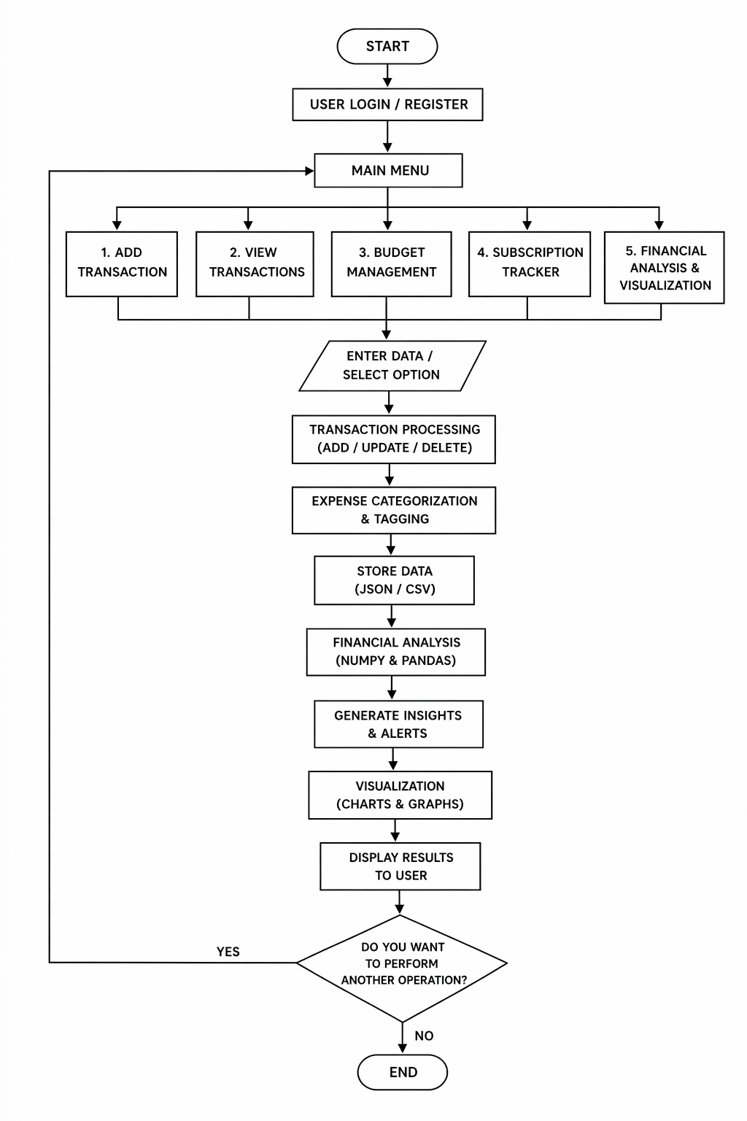
ALGORITHM

- Start
- Display login/register option for the user.
- Show the main menu with modules like transaction management, budgeting, subscription tracker, and financial analysis.
- Accept the user’s choice.
- If the user selects transaction management, add, update, delete, search, or view transactions.
- Categorize expenses and assign tags based on rules.
- Store the transaction details in JSON or CSV files.
- If the user selects budgeting, check monthly budget and goal progress.
- If the user selects a subscription tracker, identify recurring payments and predict next billing dates.
- Analyze stored financial data using NumPy and Pandas.
- Generate insights such as spending patterns, alerts, anomalies, and future expense prediction.
- Display charts and graphs for visualization.
- Ask the user whether to perform another operation.
- If yes, return to the main menu; otherwise, stop the program.
- End.

.

IMPLEMENTATION

# week1.py
date = input("Enter date: ")
amount = float(input("Enter amount: "))
t_type = input("Enter type: ")
merchant = input("Enter merchant: ")
if amount > 0:
print("Date:", date)
print("Amount:", amount)
print("Type:", t_type)
print("Merchant:", merchant)
else:
print("Invalid amount")

# week2.py
date = ""
amount = 0
t_type = ""
merchant = ""
saved = False
while True:
print("1.Add 2.View 3.Exit")
ch = input()
if ch == "1":
date = input("Date: ")
amount = float(input("Amount: "))
t_type = input("Type: ")
merchant = input("Merchant: ")
saved = True
elif ch == "2":
if saved:
print(date, amount, t_type, merchant)
else:
print("No data")
elif ch == "3":
Break

# week3.py
transactions = []
while True:
print("1.Add 2.View 3.Exit")
ch = input()
if ch == "1":
date = input()
amount = input()
t_type = input()
merchant = input()
transactions.append([date, amount, t_type, merchant])
elif ch == "2":
for t in transactions:
print(t)
elif ch == "3":
break

# week4.py
transactions = []
def add():
date = input()
amount = float(input())
t_type = input()
merchant = input()
transactions.append([date, amount, t_type, merchant])
def view():
for t in transactions:
print(t)
while True:
print("1.Add 2.View 3.Exit")
ch = input()
if ch == "1":
add()
elif ch == "2":
view()
elif ch == "3":
Break

# week5.py
transactions = {}
id = 1
while True:
print("1.Add 2.View 3.Exit")
ch = input()
if ch == "1":
date = input()
amount = float(input())
t_type = input()
merchant = input()
transactions[id] = (date, amount, t_type, merchant)
id += 1
elif ch == "2":
for i in transactions:
print(i, transactions[i])
elif ch == "3":
Break

# week6.py
class Transaction:
def __init__(self, d, a, t, m):
self.date = d
self.amount = a
self.type = t
self.merchant = m
def show(self):
print(self.date, self.amount, self.type, self.merchant)
data = []
while True:
print("1.Add 2.View 3.Exit")
ch = input()
if ch == "1":
t = Transaction(input(), float(input()), input(), input())
data.append(t)

elif ch == "2":
for t in data:
t.show()

elif ch == "3":
Break

# week7.py
class Record:
def __init__(self):
self.id = 1
self.timestamp = input()
class Transaction(Record):
def __init__(self, a, t, m):
super().__init__()
self.amount = a
self.type = t
self.merchant = m
def show(self):
print(self.id, self.timestamp, self.amount, self.type, self.merchant)

# week8.py
import json
import csv
data = [{"date":"1","amount":100,"type":"d","merchant":"a"}]
# JSON
f = open("data.json","w")
json.dump(data,f)
f.close()
# CSV
f = open("data.csv","w",newline="")
w = csv.writer(f)
w.writerow(["date","amount","type","merchant"])
for t in data:
w.writerow([t["date"],t["amount"],t["type"],t["merchant"]])
f.close()

# main.py
from week6 import Transaction
t = Transaction("1",100,"d","shop")
t.show()

# __init__.py
print("Package loaded")

# week11.py
class InvalidAmountError(Exception):
pass
try:
a = float(input("Enter amount: "))
if a <= 0:
raise InvalidAmountError
print("Valid")
except InvalidAmountError:
print("Invalid amount")

# week12.py
import pandas as pd
import numpy as np
import matplotlib.pyplot as plt
df = pd.read_csv("data.csv")
print(df.groupby("merchant")["amount"].sum())
print("Average:", np.mean(df["amount"]))
plt.bar(df["merchant"], df["amount"])
plt.savefig("chart.png")

INTEGRATION AND SYSTEM TESTING
OUTPUTS

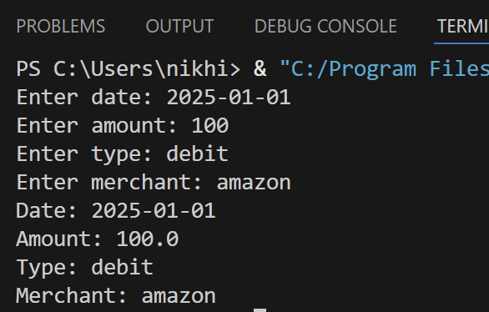
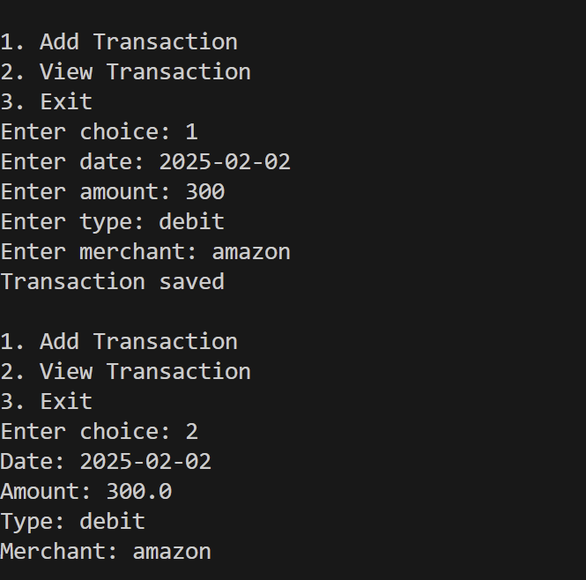

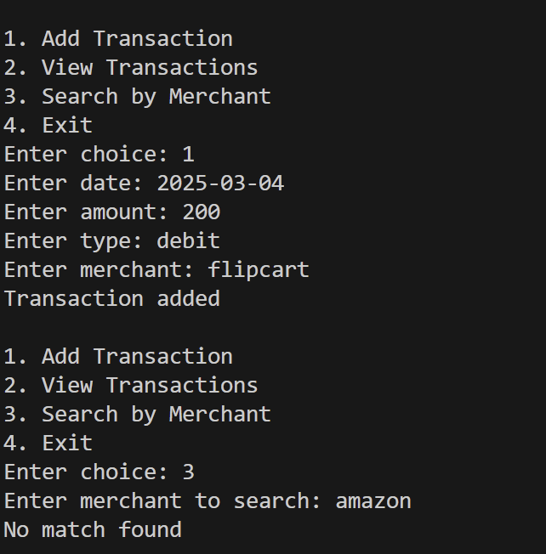 | 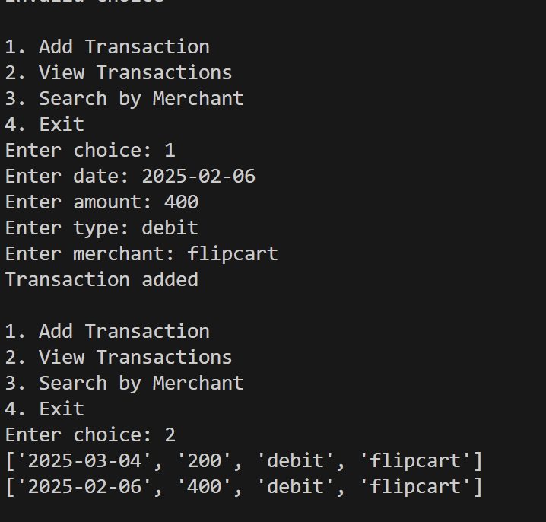
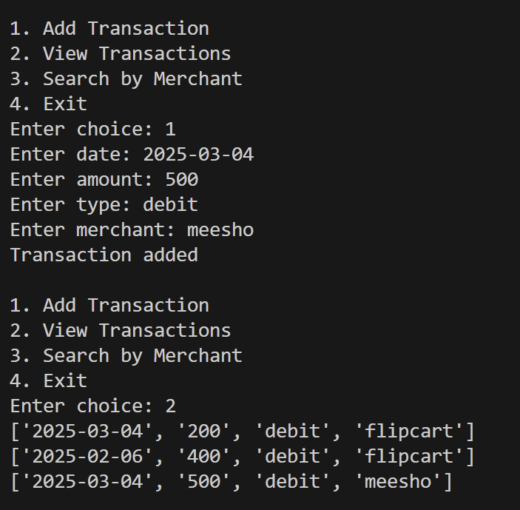 | 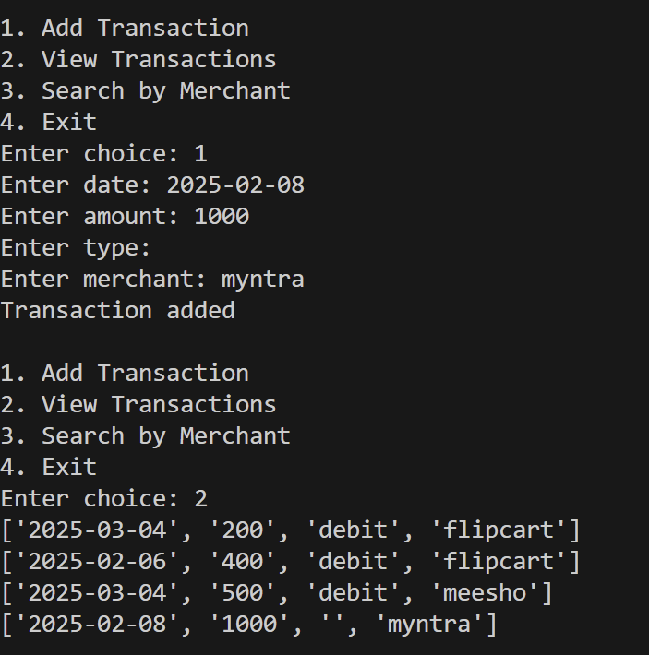
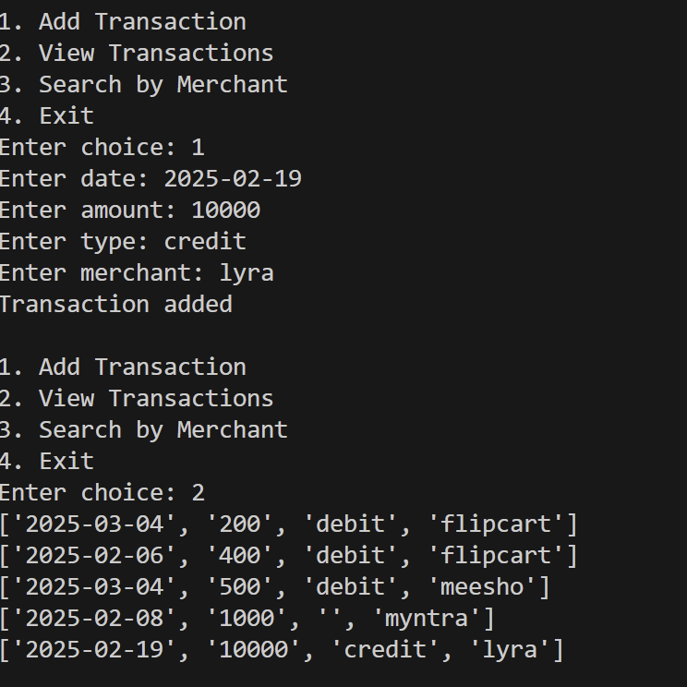 | 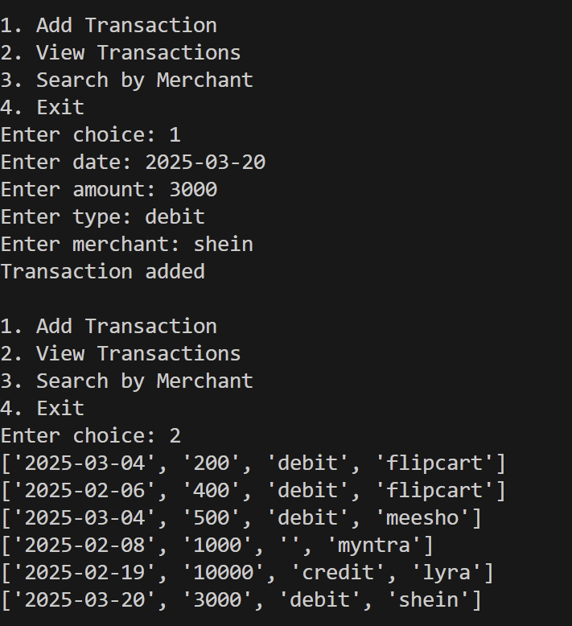

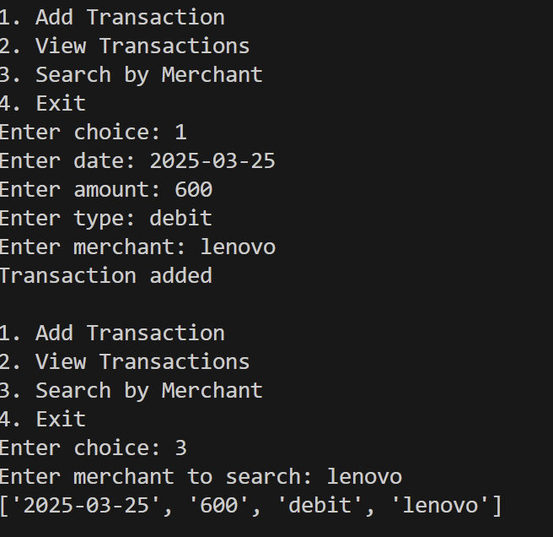 | 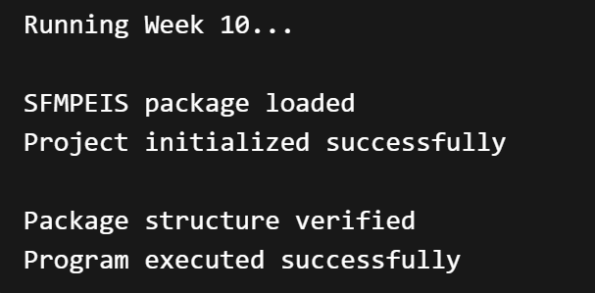
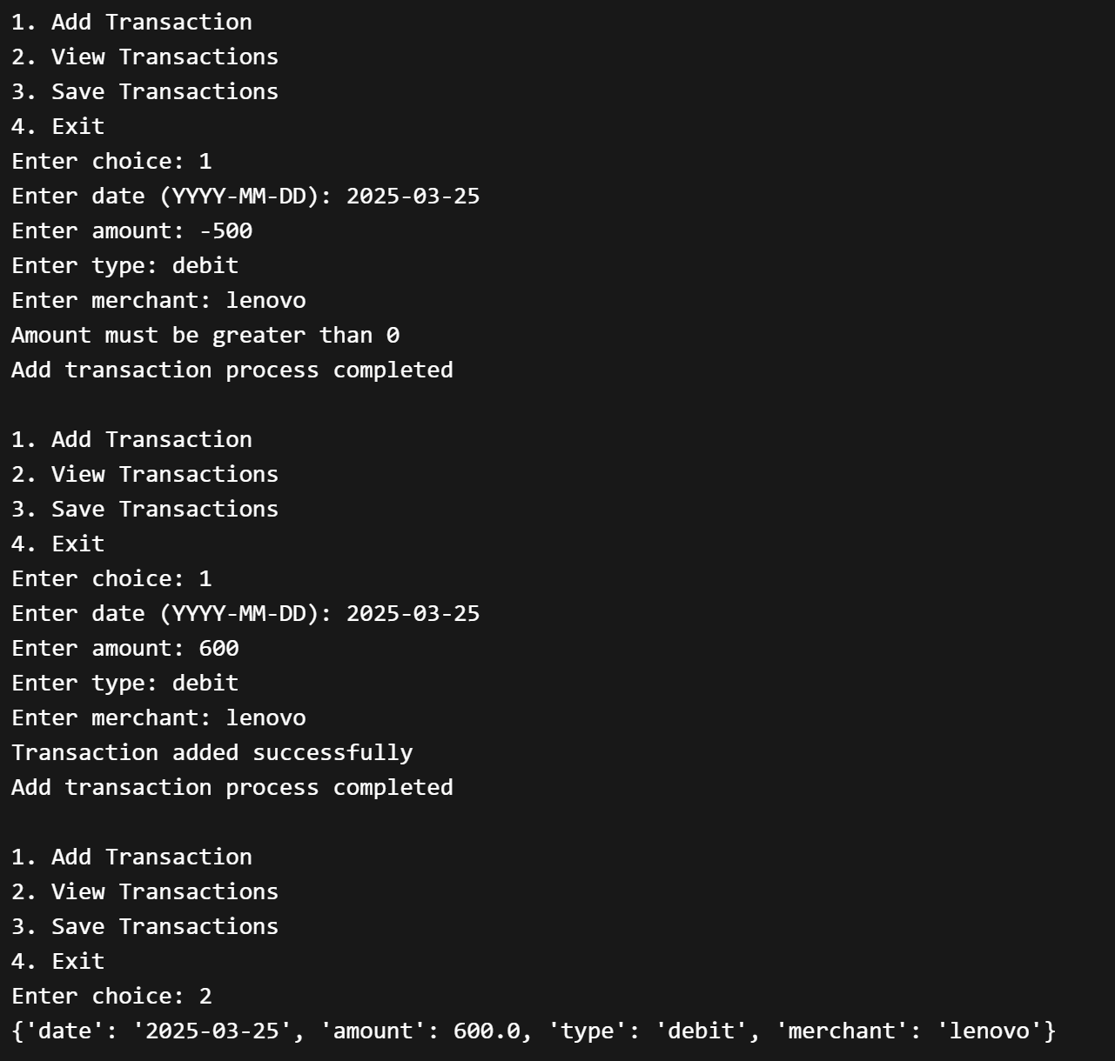 | 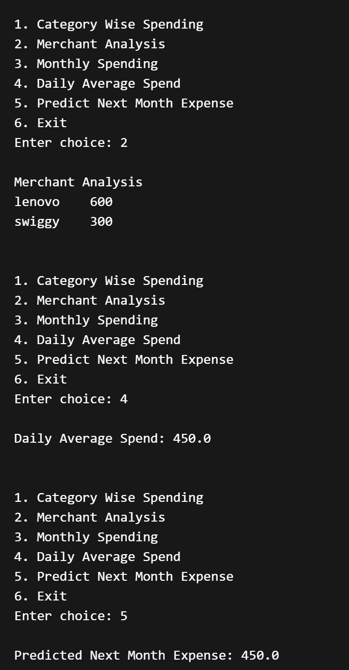

CONCLUSION

The Smart Finance Manager & Personal Expense Intelligence System (SFM-PEIS) project helped in understanding the practical implementation of Python concepts step by step. Starting from basic input and output operations, the project gradually progressed to advanced topics like data structures, object-oriented programming, file handling, modules, packages, exception handling, and data analysis.
Each module contributed to building a complete and functional finance management system. The project demonstrates how real-world applications can be developed using Python by organizing code into multiple files and applying proper programming techniques.
Through this project, we learned how to manage financial data, store and retrieve information using files, handle errors efficiently, and perform basic analytics using tools like NumPy, Pandas, and Matplotlib. The final system provides useful insights such as spending patterns, averages, and predictions.
Overall, this project enhanced our problem-solving skills, coding practices, and understanding of building structured and scalable applications.

